|  |  |
| --- | --- |
|  |  |

|  |
| --- |
| **Project 6.2.1 Circuit Design** |

Introduction

|  |  |
| --- | --- |
|  | The electronic circuit is the backbone of all electronic devices. An electronic circuit is a collection of electronic components that work together to achieve a desired result. Most devices are made up of several circuits. If you look inside something like a computer, you can see circuit boards with electronic components and electronic chips throughout. Much smaller devices also require a large number of electronic components. Engineers want everything to be smaller. Making circuits smaller allows devices to become smaller and more powerful. |

Equipment

* Circuit Design presentation
* Schematic Symbols Chart
* Engineering notebook
* Snap Circuits® components
* Board, voltage source and power supply
* 3 Lights
* Various sizes of snap wires

Procedure

1. In teams of two, you will create series, parallel, and combination circuits and answer fundamental questions about their operation. Complete the circuits and engineering journal entries as outlined in the Circuit Design presentation.
2. Complete the Schematic Symbols Chart as you learn about different electronic components and functions.
3. What are the three requirements of a circuit?

Source of electrons

Pathway

Load device

Define a series circuit.

A circuit that contains only one path for current to flow.

Draw the schematic for the series circuit.

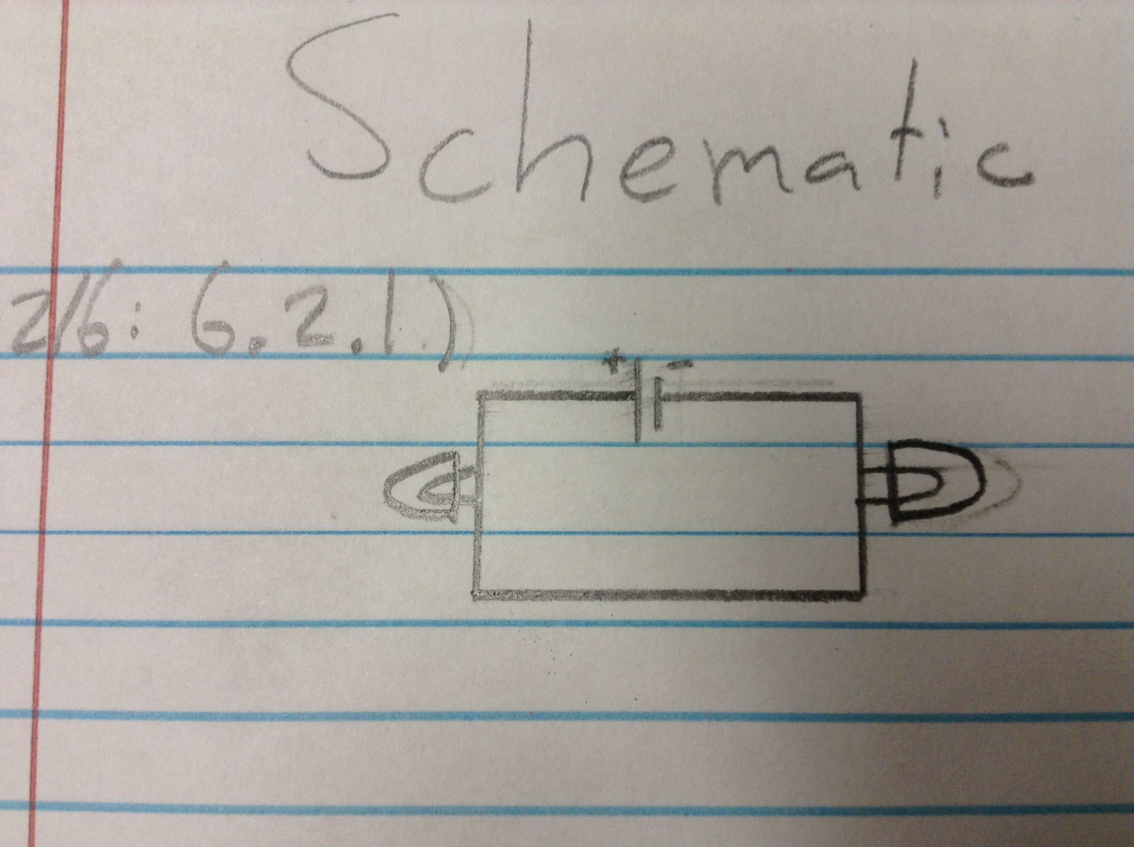

Define a parallel circuit.

A circuit that contains more than one path for current to flow.

Draw the schematic for the parallel circuit.

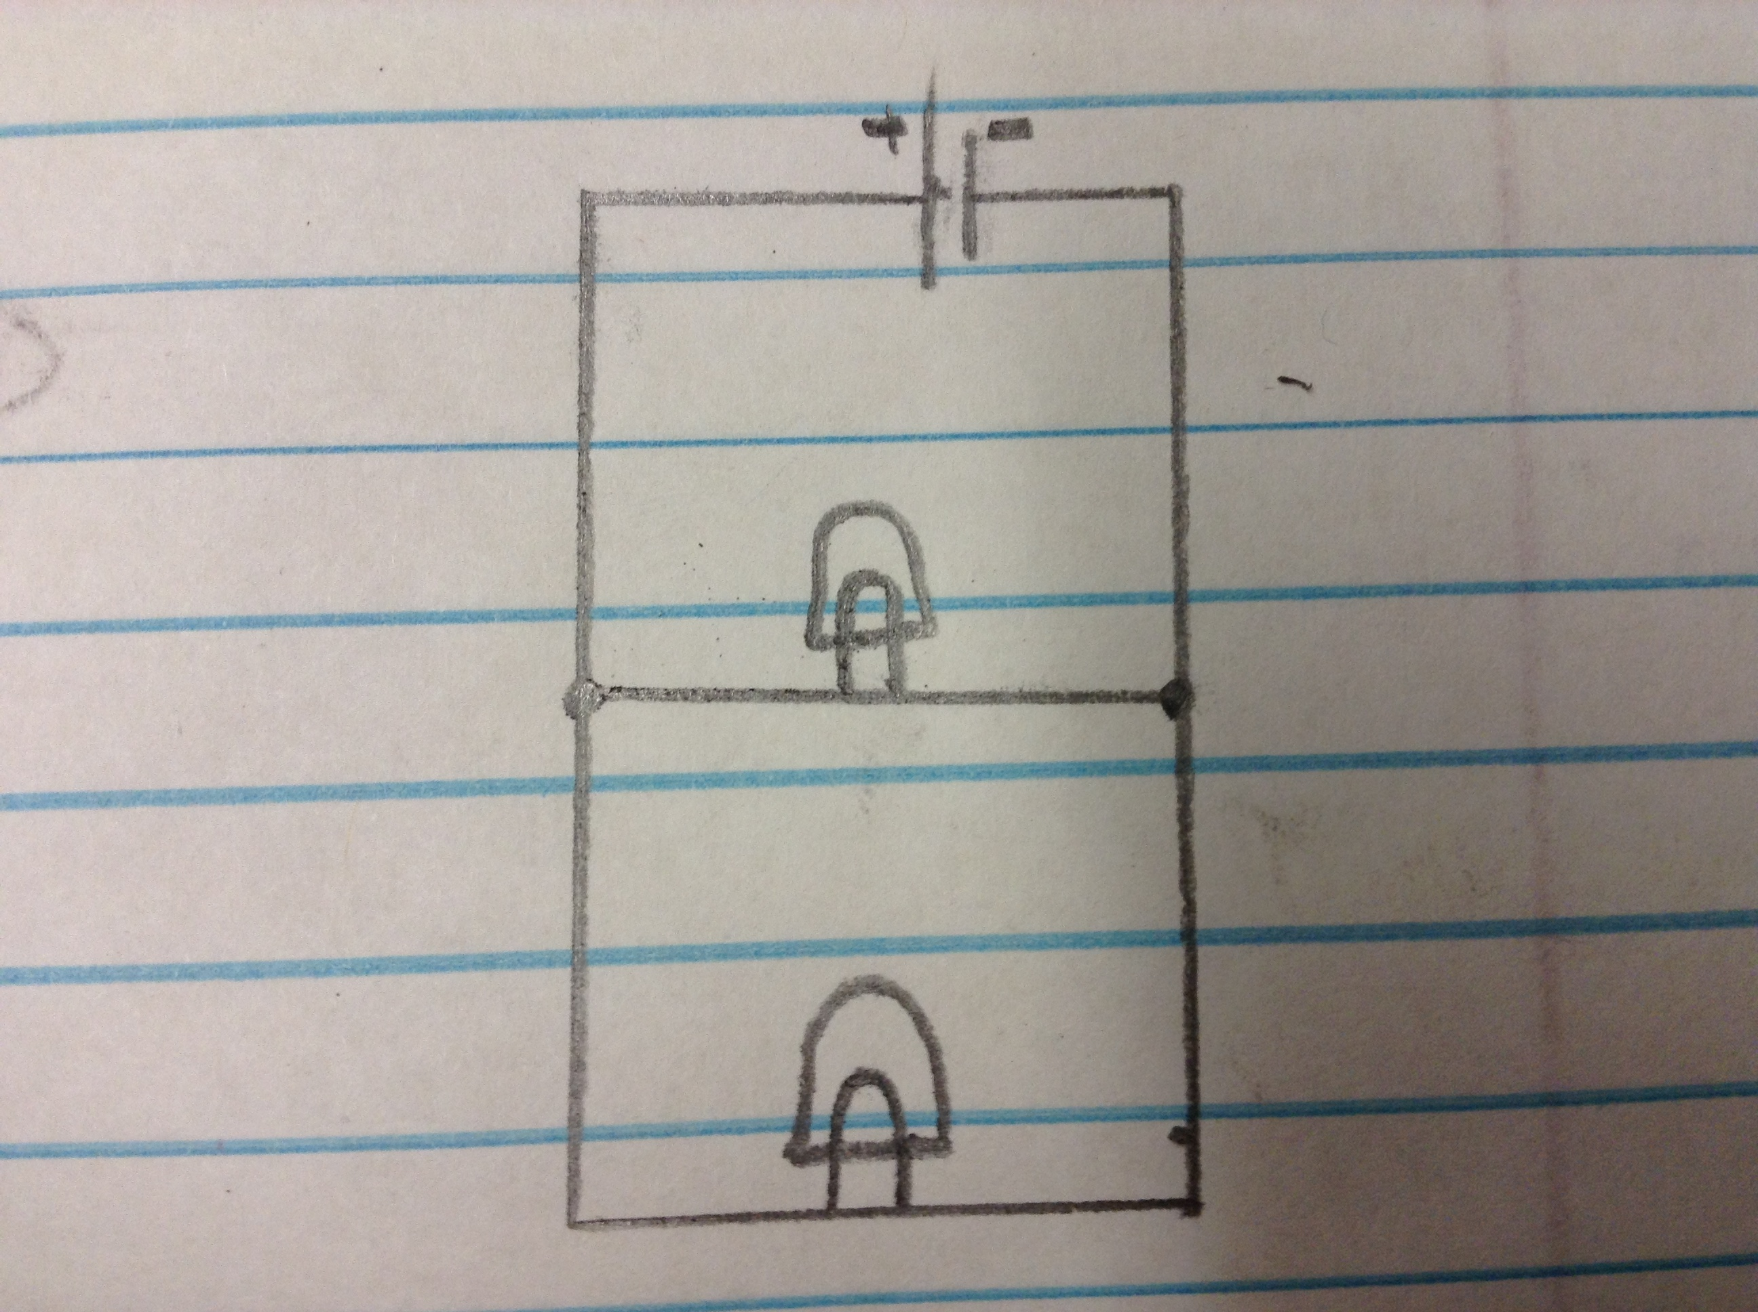

Define a combination circuit.

A circuit that contains both series and parallel arrangements.

Draw the schematic for the combination circuit.

Using the schematics you drew of the pictures in the presentation, build the following circuits. Be sure to have your instructor sign your paper for confirmation.

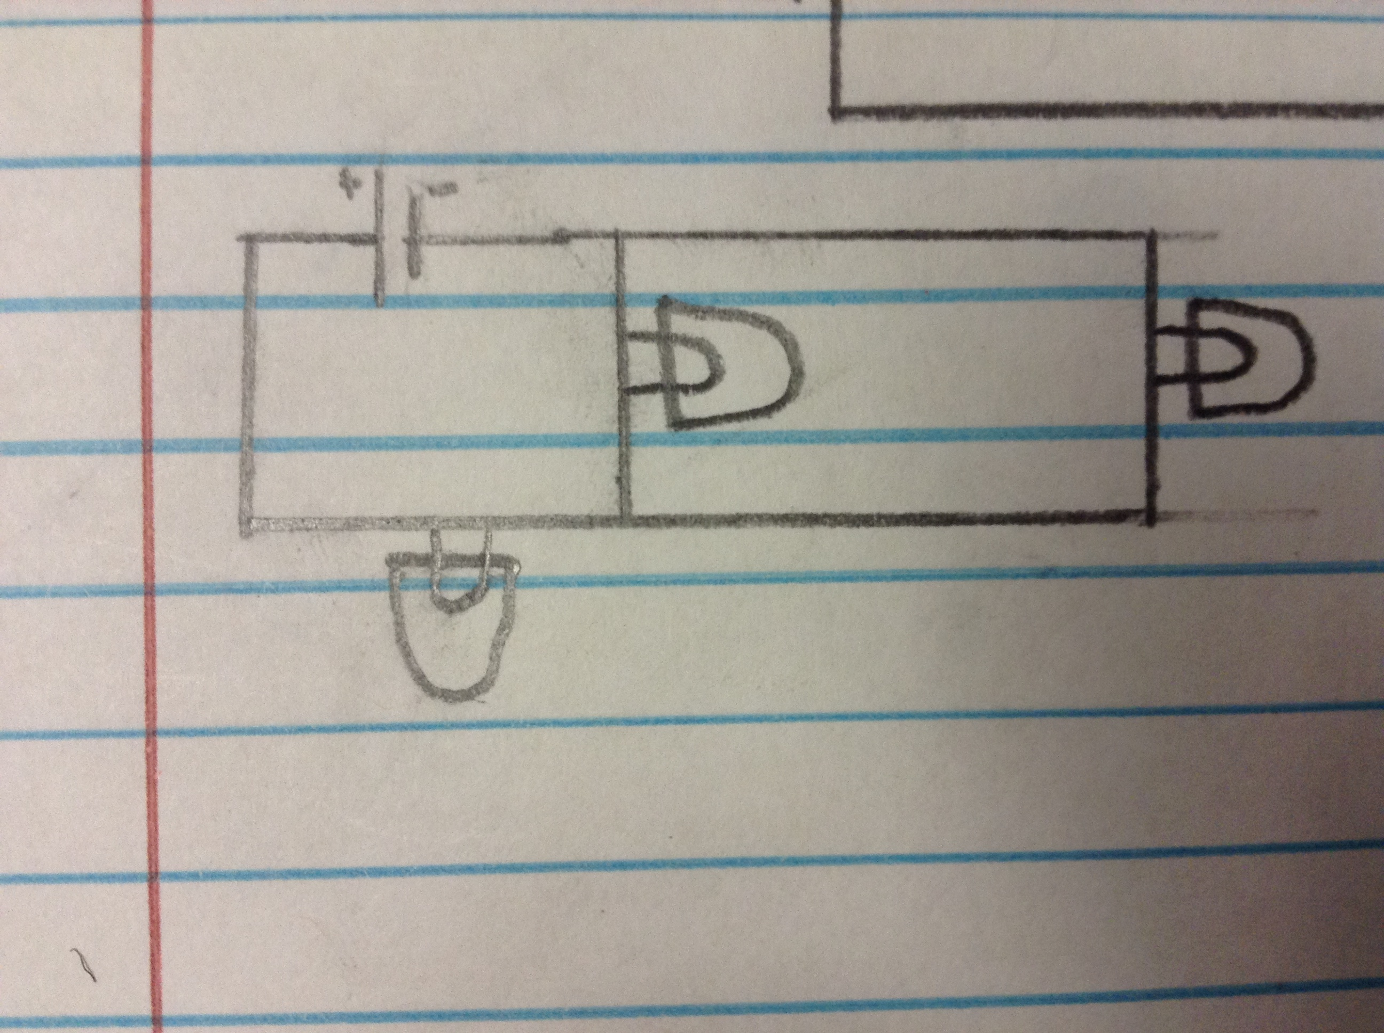

Series Circuit:

Circuit Construction ______________

Observations:

1. What is the brightness of the bulbs?

Very bright

1. When a bulb is disconnected, what happens to the remaining bulb?

The remaining bulb went out.

1. Why?

Because the circuit was broken and the electrons couldn’t flow through the second bulb.

Parallel Circuit:

Circuit Construction ______________

Observations:

1. What is the brightness of the bulbs?

Extremely bright

1. When a bulb is disconnected, what happens to the remaining bulb?

The other bulb stays lit.

1. Why?

Because the electrons have another path to the second bulb that wasn’t interrupted when the first was taken out.

Combination Circuit:

Circuit Construction ______________

Observations:

1. What is the brightness of the bulbs?

The parallel bulbs are very dim, but the series bulb is bright.

1. When the series bulb is disconnected, what happens to the remaining bulb?

The other two parallel bulbs go out.

1. Why?

Because the flow of electrons is stopped and can’t flow to the other bulbs.

1. When one of the parallel bulbs is disconnected, what happens to the remaining bulbs?

The other bulbs stay lit.

1. Why?

Because electrons can flow through another path that includes the other bulbs.

Conclusion

1. Describe an application where a series circuit might work better than a parallel circuit.

A series circuit would work better for ceiling lights because you would want all the lights to turn on or off when you flipped the switch, not just interrupting the current of one.

1. Describe an application where a parallel circuit might work better than a series circuit.

A parallel circuit would work better in a strand of Christmas lights because one bad light wouldn’t affect the entire strand since there would be multiple paths for the electrons to flow.

1. A security system uses sensors at every door and window which will set off an alarm if any one of them is opened. There is also a keypad by an entry door to turn on or turn off the system. Describe how these components can be wired in a combination circuit to provide the needed security.

All of the sensors would be combination circuits because every time a door is opened, that part of the circuit would be broken and another path is used to activate the alarm. The entire circuit isn’t relying on one part. The keypad would have to be a series circuit to turn off all the alarms at once.

1. Discuss your theory on why the light bulbs in the combination circuit have different brightness.

The series bulb was closest to the power source and all the electrons had to flow through it. The parallel bulbs were dimmer because they had to share current with different 2 paths the electrons had to flow through.